*2025*

*EDITION*

Wedding



*PRESENT BY: LE CELLIER DU ROI & LE ROYAL BROMONT*



**SUMMARY**

**03**

## INTRODUCTION

The Royal Bromont and the Cellier du Roi, the ideal place to celebrate your wedding

**04**

***ROYAL WEDDING PACKAGE & MENUS***

Discover our Royal package as well as our services for a successful day, hassle-free

**08**

## BANQUET HALL

Venue available for small and larger groups

**09**

## PARTNERS

Accommodation, event product rentals, church.

**INTRODUCTION**

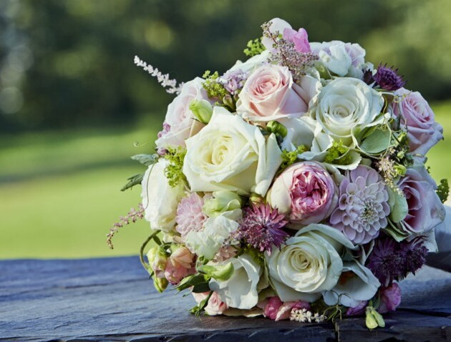

# CELEBRATION

For an unforgettable wedding, Le Cellier du Roi is the ideal place. With a breathtaking view of the surrounding mountains and open year-round, our reception room can accommodate up to 140 guests in a warm and renewed atmosphere.

# PROCESS

The process is simple and efficient. It will be our pleasure to inform you, during a first meeting, about the various possibilities offered by a wedding at the Royal Bromont. Our professional team will be happy to assist you on this special day.

Several meetings, by phone or in person, depending on your availability, will lead to a well-organized day with no surprises.

We understand that this day must be a high level success and we are at your disposal so that it is in your image and established according to your budget.

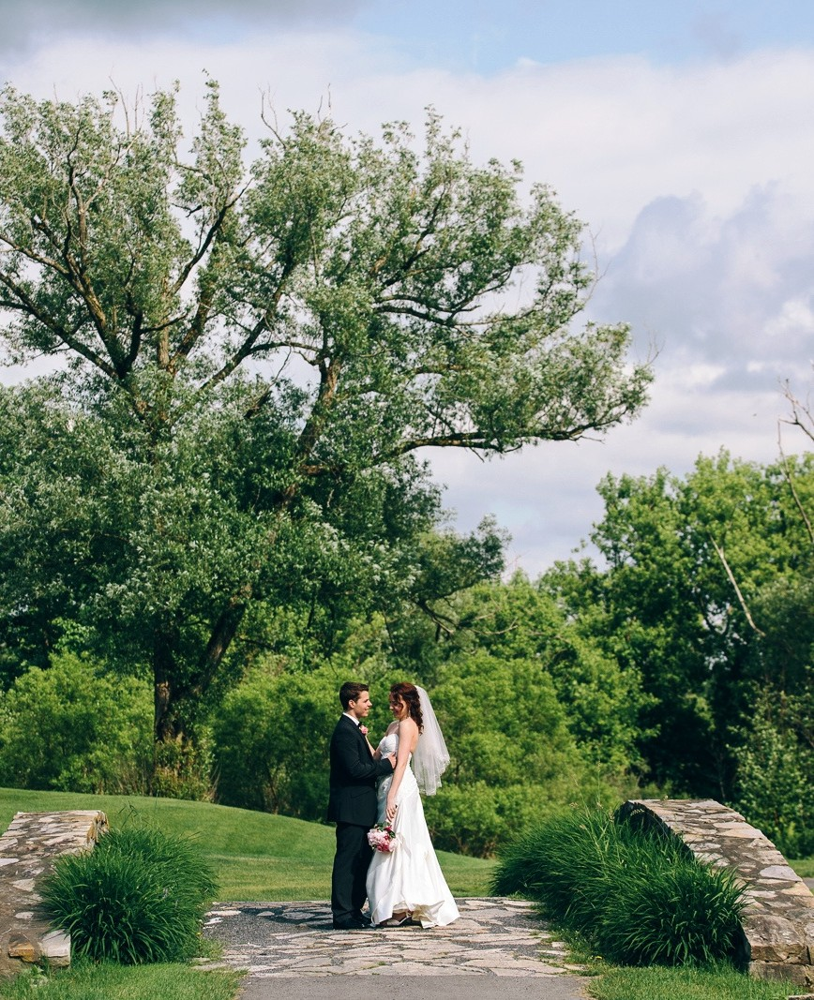

P A G E 3

**ROYAL PACKAGE**



1 wine reception (1 glass of white or sparkling wine, sommelier's choice)

3 cocktail bites (to choose from the tasting bites) A 3-course meal.

Half a bottle of wine per person Golf cart for taking photos

Free parking

Setting up tables (white tablecloths and napkins, banquet chairs) Private windowed room, a maximum of 140 people including, dance floor, integrated speaker system, microphone, screen and projector.

##### FROM $ 125 PER PERSON

taxes and service not included.

## Other services

Ceremony on the golf course - $ 350 Chair rental (to your own expense) Cut of cake - $ 4 per person

## Items supported by the bride and groom

DJ service, musicians, decoration, flowers, wedding cake, dressing of chairs, centerpieces, consulting service by a planner, photographer, a celebrant, etc.

P A G E 4

**BOUCHÉES - APPETIZERS**

**BOUCHÉES FROIDES / *COLD APPETIZERS***

**BOUCHÉES FROIDES / *COLD APPETIZERS***

* CANNELLONI DE JAMBON PROSCIUTTO, ÉCRASÉE DE POMMES DE TERRE ET PISTACHE (SANS GLUTEN) / *PROSCIUTTO CANNELLONI, MASHED POTATOES AND PISTACHIO (GLUTEN FREE)*
* CHOU FARCI AU FROMAGE DE CHÈVRE ET NOISETTES TORRÉFIÉES / *PROFITEROLE STUFFED WITH GOAT CHESSE AND ROASTED HAZELNUTS*
* TOAST AUX RILLETTES DE THON AU FROMAGE À LA CRÈME ET CURRY / *TOAST WITH TUNA RILLETTE WITH CREAM CHEESE AND CURRY*
* PAIN D’ÉPICES, CAVIAR AUBERGINE ET SAUMON FUMÉ / *GINGERBREAD, WITH EGGPLANT CAVIAR AND SMOKED SALMON*
* TARTARE DE LÉGUMES À L'ASIATIQUE (VÉGÉTARIEN) / ASIATIC VEGETABLE TARTARE (VEGETERIAN)

**VERRINES FROIDES / COLD SHOT GLASS**

* HOUMOUS DE POIS CHICHES À L’HUILE DE SÉSAME ET BRISURES DE CREVETTES (SANS GLUTEN) / *CHIKPEA HUMMUS WITH SESAME OIL AND SHRIMP (GLUTEN FREE)*
* MOUSSELINE DE PATATES DOUCES AU SIROP D’ÉRABLE ET TARTARE D’AVOCAT (SANS GLUTEN ET VÉGÉTARIEN) /*SWEET POTATO MOUSSELINE WITH MAPLE SYRUP AND AVOCADO TARTARE (GLUTEN FREE AND VEGETARIAN)*

**BOUCHÉES CHAUDES / *HOT APPETIZERS***

* ARANCINI DE RISOTTO AU PARMESAN AUX ÉCLATS DE NOIX / *PARMESAN RISOTTO ARANCINI WITH NUT SLIVERS*
* CROUSTILLANT DE MACREUSE DE BŒUF FAÇON TEXANE / *CRISPY BEEF MACREUSE THE TEXAN WAY*
* BEIGNET DE MORUE AU BRIE FONDANT / *COD FRITTER WITH MELTED BRIE CHEESE*

P A G E 5

**BANQUET MENU**

***MENU (à titre d’exemple) / MENU (EXAMPLE)***

#### 3 SERVICES / THREE COURSE MEAL

1 ENTRÉE, 1 PLAT PRINCIPAL ET 1 DESSERT INCLUS

1 APPETIZER, 1 MAIN AND 1 DESSERT INCLUDED

#### 4 SERVICES / FOUR COURSE MEAL

2 ENTRÉES, 1 PLAT PRINCIPAL ET 1 DESSERT **12$** EN SUPPLÉMENT

2 APPETIZERS, 1 MAIN AND 1 DESSERT **12$** SUPPLEMENT

***SELON LE MENU DÉSIRÉ, EFFECTUER LES CHOIX PARMI LES PLATS SUIVANTS :***

***ACCORDING TO YOUR MENU CHOICE, YOU NEED TO MAKE YOUR SELECTION AMONG THE FOLLOWING ITEMS***

***ENTRÉES / APPETIZERS***

* VELOUTÉ DE LÉGUMES, CROQUANT DE LÉGUMES DU MARCHÉ ET CRUMBLE DE NOISETTE / *CREAM OF VEGETABLE, HAZELNUT CRUMBLE AND VEGETABLE TARTAR*
* FEUILLETÉ DE VOLAILLE À L’INDIENNE, SAUCE CRÉMEUSE AU LAIT DE COCO / *INDIAN-STYLE POULTRY PUFF PASTRY,*

*CREAMY COCONUT MILK SAUCE*

* TARTARE DE LÉGUMES FAÇON CAPONATA, COULIS DE TOMATE ET BASILIC / *MEDITERRANEAN CAPONATA, TOMATO*

*AND BASIL COULIS*

* PAIN FONDANT AU PROSCUITTO ET PARMESAN, CRÈME LÉGÈRE À LA MOUTARDE À L’ANCIENNE / *MELT-IN-THE-MOUTH BREAD WITH PROSCUITTO AND PARMESAN, LIGHT CREAM WITH OLD-FASHIONED MUSTARD*
* CARPACCIO DE TOMATES ANCESTRALES (EN SAISON), FETA ET PANCETTA, HUILE DE MENTHE / *ANCESTRAL TOMATO (IN SEASON) CARPACCIO, FETA AND PANCETTA, MINT OIL*
* GRAVLAX DE SAUMON AU POIVRE ROSE ET GIN DU QUÉBEC, BRIOCHE GRILLÉE ET CHUTNEY D’OIGNONS ROUGES / *SALMON GRAVLAX WITH PINK PEPPER AND QUÉBEC GIN, TOASTED BRIOCHE AND RED ONION CHUTNEY*

***PLATS / MAINS***

* SAUMON FRAIS DU CANADA CUIT À BASSE TEMPÉRATURE, CRÉMEUX DE POIVRON ROUGE / *FRESH CANADIAN SALMON COOKED AT LOW TEMPERATURE, RED BELL PEPPER CREAM*
* MACREUSE DE BŒUF FONDANTE ET SNACKÉE À LA PLANCHA / *MELT-IN-THE-MOUTH BEEF SKIRT STEAK, SNACKED A LA PLANCHA*
* SUPRÊME DE POULET RÔTI EN CUISSON LENTE, SAUCE VIN ROUGE / *SLOW-COOKED ROAST CHICKEN SUPREME,*

*RED WINE SAUCE*

* GIGOT D’AGNEAU CONFIT AU PESTO ET SON JUS CORSÉ / *LEG OF LAMB CONFIT WITH PESTO AND WITH FULL-BODIED JUS*
* ARANCINIS DE RISOTTO D’ORZO AU BASILIC ET COULIS DE BETTERAVE ROUGE / *ORZO BASIL RISOTTO ARANCINI AND BEET COULIS*

TOUS LES PLATS SONT ACCOMPAGNÉS DE LÉGUMES DE SAISON. VOUS DEVEZ ÉGALEMENT FAIRE UN (1) CHOIX UNIQUE D’ACCOMPAGNEMENT POUR TOUS: ÉCRASÉ DE POMMES DE TERRE AU BEURRE NOISETTE OU GRATIN DAUPHINOIS*ALL DISHES ARE ACCOMPANIED BY SEASONAL VEGETABLES. YOU MUST ALSO MAKE ONE (1) SINGLE CHOICE OF SUPPORT FOR EVERYONE: MASHED POTATOES WITH BROWN BUTTER OR GRATIN DAUPHINOIS*

***DESSERT***

* AU CHOIX DU CHEF – CHOIX UNIQUE / *CHEF’S CHOICE (SAME DESSERT FOR ALL)*

P A G E 6

NO REDUCTION IN THE NUMBER OF GUESTS WILL BE ACCEPTED 7 DAYS BEFORE THE EVENT.

PLEASE NOTE THAT THE MENU AND THE PRICES ARE SUBJECT TO CHANGE WITHOUT NOTICE.

P A G E 7

### PROCÉDURE POUR LE MENU BANQUET

**BANQUET MENU**

SÉLECTION DE 2 CHOIX D’ENTRÉES PARMI LA LISTE SÉLECTION DE 2 CHOIX DE PLATS PRINCIPAL PARMI LA LISTE UN CHOIX D’ACCOMPAGNEMENT POUR TOUS

SÉLECTION D’UN DESSERT UNIQUE POUR TOUS

LES CHOIX DOIVENT ÊTRE FAIT D’AVANCE ET IDENTIFIER DEVANT CHAQUE INVITÉ AU MOYEN DE MARQUES-PLACES.

#### CHOIX SUPPLÉMENTAIRE

L’AJOUT DE CHOIX DE PLAT SUPPLÉMENTAIRE À LA SÉLECTION ENGENDRERA DES FRAIS DE 5$ PAR PERSONNE PAR SERVICE AJOUTÉ.

LA SÉLECTION DU MENU DE CHAQUE CONVIVE DEVRA ÊTRE REMISE AU MOINS 2 SEMAINES AVANT L’ÉVÈNEMENT.

AUCUNE DIMINUTION DU NOMBRE DE CONVIVES NE SERA ACCEPTÉE 7 JOURS AVANT L’ÉVÈNEMENT. PRENEZ NOTE QUE LE MENU ET LES TARIFS SONT SUJET À CHANGEMENT SANS PRÉAVIS

### PROCEDURE FOR THE BANQUET MENU

SELECTION OF 2 CHOICES OF ENTRIES FROM THE LIST SELECTION OF 2 MAIN DISHES FROM THE LIST

SAME CHOICE OF SIDE ORDERS FOR ALL SELECTION OF A UNIQUE DESSERT FOR EVERYONE

CHOICES SHOULD BE MADE IN ADVANCE AND IDENTIFIED IN FRONT OF EACH GUEST WITH PLACE CARDS.

#### ADDITIONAL CHOICE

ADDING A SELECTION OF MAIN COURSE TO THE MENU WILL RESULT IN $ 5 FEE PER PERSON PER SERVICE ADDED. THE SELECTION OF THE CHOICES OF EACH GUEST MUST BE GIVEN AT LEAST 2 WEEKS BEFORE THE EVENT.

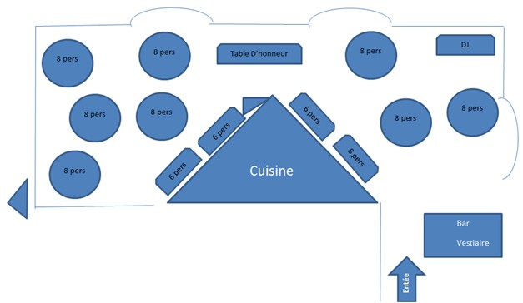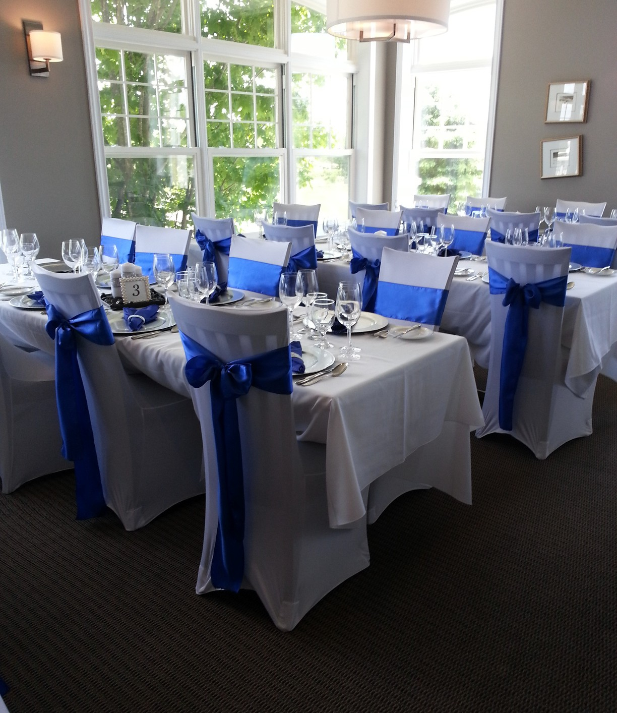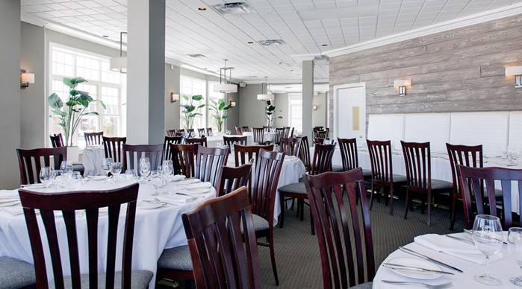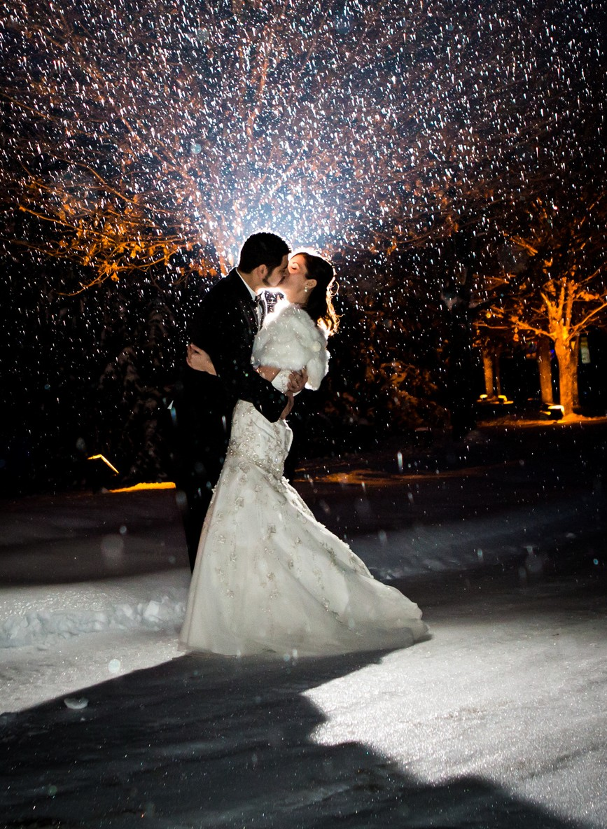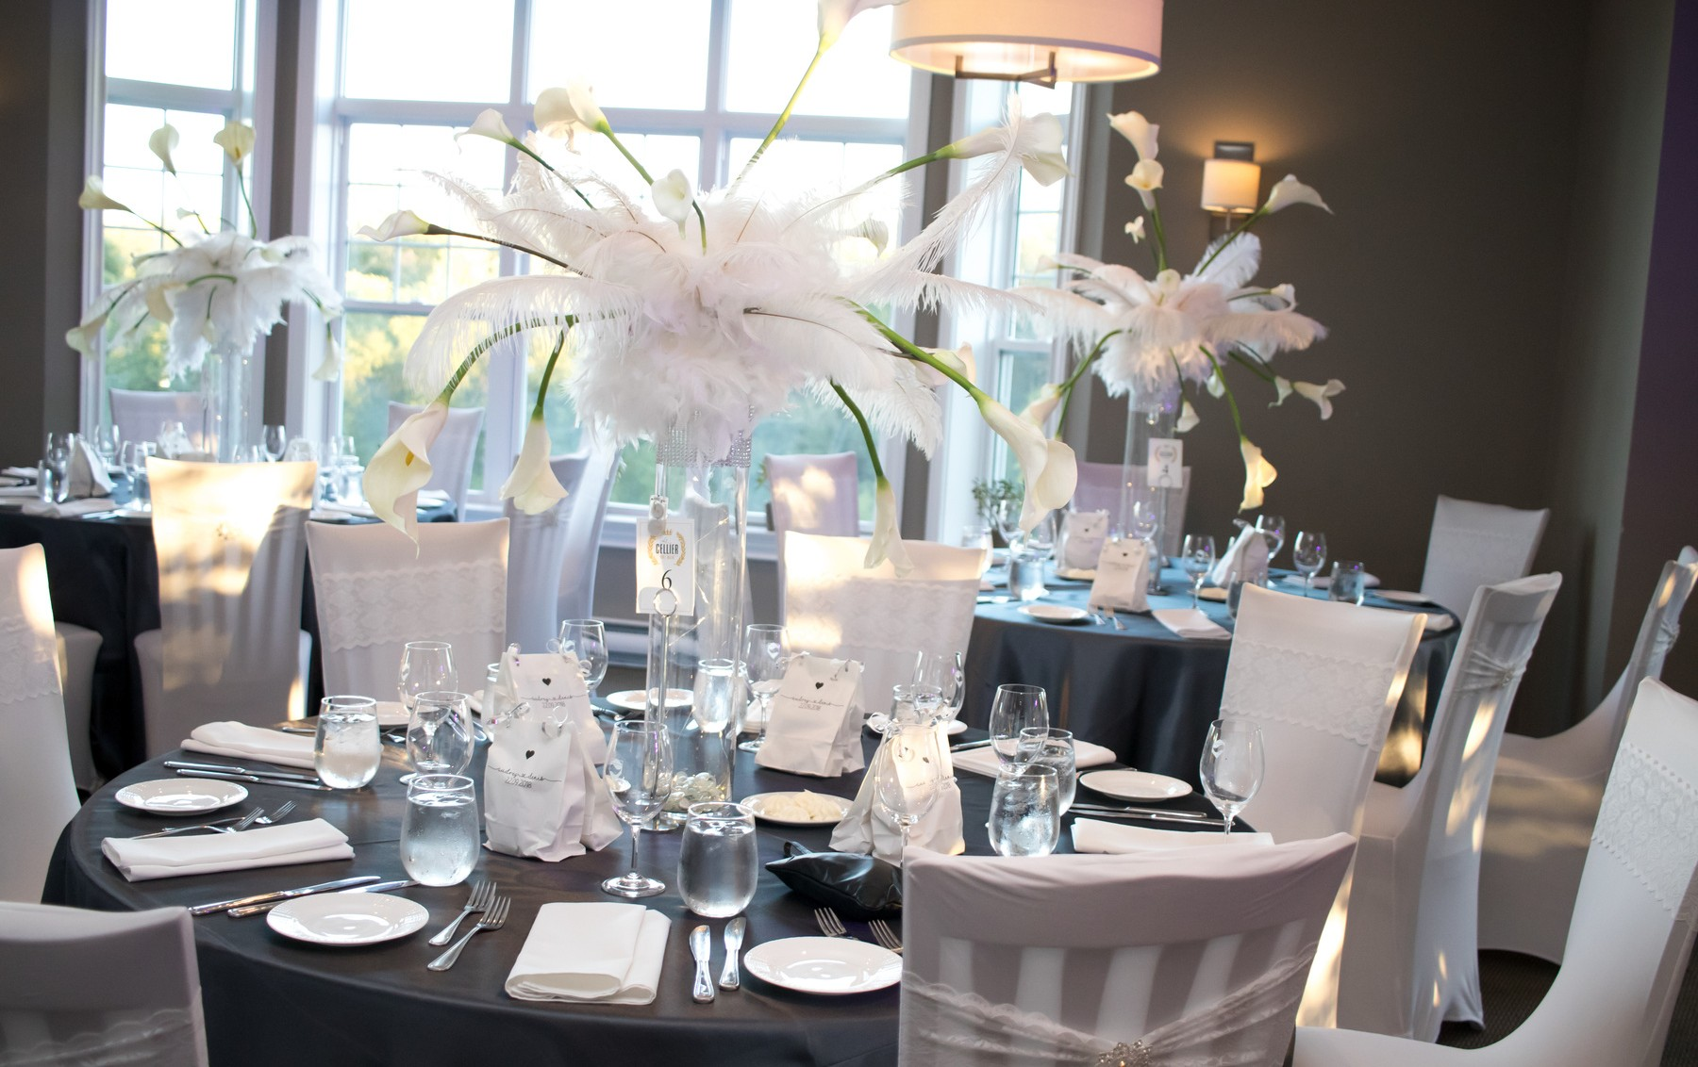

**BANQUET FACILITIES**

# INFORMATION

We have 2 rooms: one with a capacity of 26 people, the second can accommodate up to a maximum of 140 people.

Our ceremony site is located approximately 100 meters from the pavilion.

# CONFIGURATION

The François 1er banquet hall can be configured in several ways and can use different shapes of tables depending on the desired capacity. Note that we can section the room for smaller groups.

P A G E 8

**OUR PARTNERS**

# ACCOMMODATION

[**https://tourismebromont.com/attrait/ou-dormir/**](https://tourismebromont.com/attrait/ou-dormir/)

For all your accommodation needs, our tourism office can meet your needs. You can reach them at

[**450 534-2006**](tel:+14505342006)

or

[tourisme@bromont.com](mailto:tourisme@bromont.com)

# OTHER SERVICES

#### Le Vaisselier

We offer a clé en main formula: whether for a birthday, for a barbecue or for a large-scale project such as your wedding, we have the resources and solutions to make your event unforgettable.

Our goal is to make your life easier by offering a range of rental products and exceptional service. We will meet your needs to make your organizational task easier.

**Catholique Church** Saint-François-Xavier 650, rue Shefford, Bromont, Qc,

J2L 1C1

Téléphone : (450) 534-2181

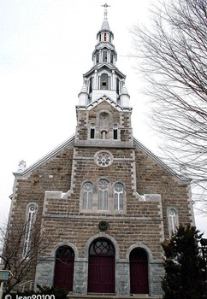

P A G E 9